# Semester Project Phase 2 (Accessibility) – Group B

GROUP OVERVIEW – GROUP B

## Group Members

* **Michael Ng**: Team Leader
* **Emily Ervin**: Document Manager
* **Preston Ware**: Lead Developer
* **Aaron Henderson**: Lead Designer
* The Quality Manager is shared equally across the team.
* Our team communicates using Discord. We also have set up a GitHub repository for later use.
* We meet using Zoom, and meetings prior to the 2nd interview have been recorded (inclusive).

## Client Information

* **Client**: Lindsay Roberts
* **Business**: Twisted Vinyl
* Lindsay Roberts is the owner of a small family business named “Twisted Vinyl”.
* The company mainly sells decorated T-Shirts, but also do other types of decorations such as Sublimination Printing, Vinyl decals on car windows, home decorations, etc.
* She plans on updating the website on the days to come and hopes to turn the company into a profitable and formal business.



## Site Mission Statement

* *To make sure our customers are happy with the finished design.*

Accessibility

### Michael Ng: Justin Time (Group A Male)

Justin Time is a College Sophomore, and likes to tell jokes and hang out with friends. Impairments: Colorblind.


**Concern**: Justin Time is mostly colorblind, only being able to make out strong differences in color.

**Resolution**: The website will have a sharp difference between the website’s theme and the color of the text on the website. (This may be tested using Windows 10’s Color filters setting. Setting the color filter to “**Grayscale**” will turn all colors into different shades of white, gray, or black.)

### Michael Ng: Mina Time (Group B Female)

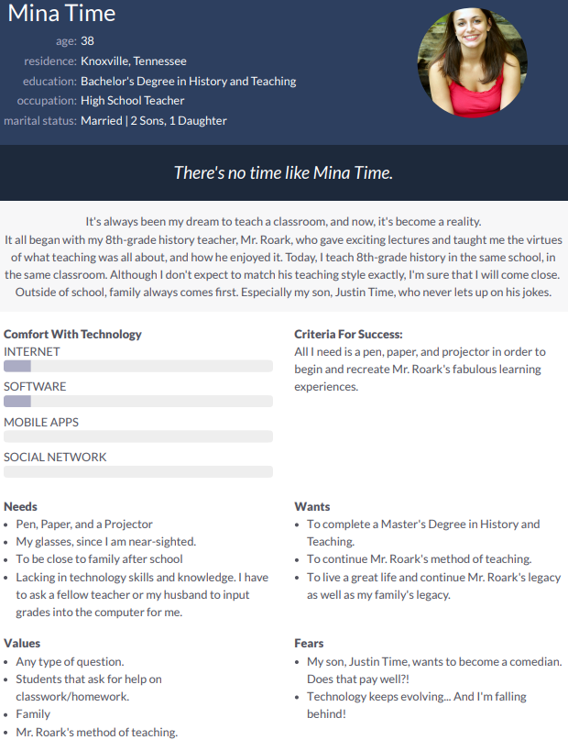

**Concern**: Mina Time is terribly unexperienced with computer technology and needs help navigating through a webpage.

**Resolution**: The layout of the website will be very easy to navigate. The search bar will be emphasized so it will be difficult to miss and will have the text “Tell us what you are looking for!” as background text in the bar.

### Preston Ware: Suzi Blevins (Group A Female)

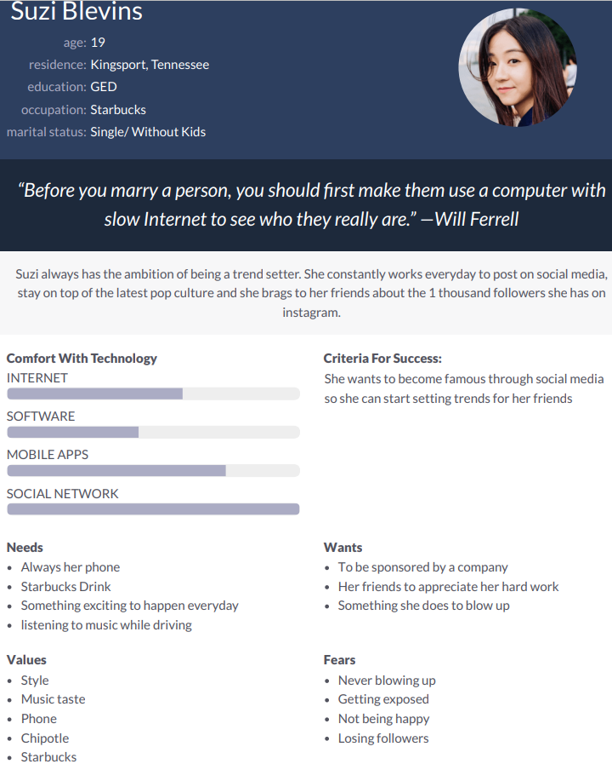

**Concern**: Suzi Blevins enjoys websites that appear trendy or styled. She may not stay on the website long if the website does not match the prerequisites.

**Resolution**: Featured products on the homepage will (typically) be trendy products designed to catch anyone’s attention.

### Preston Ware: Maleko Obama (Group B Male)

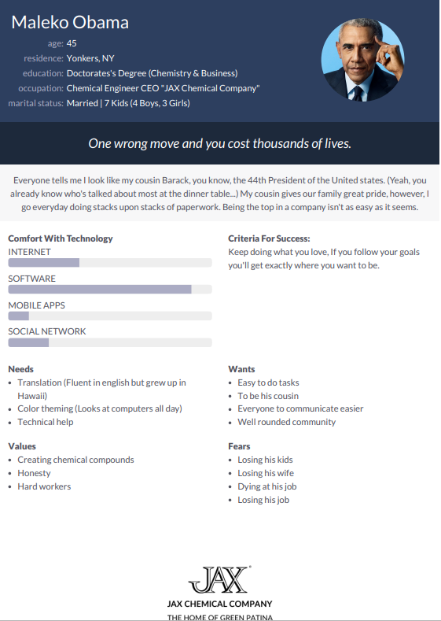

**Concern**: Maleko Obama is an extremely busy man and requires the website to be fast and have the checkout process be easy-to-understand and quick.

**Resolution**: The website may be formatted in a way to allow quick navigation and checkout.

### Aaron Henderson: Todd Miller (Group B Male)

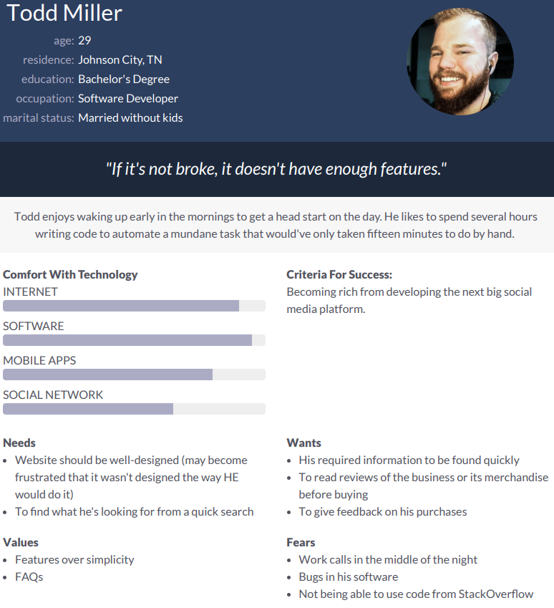

**Concern**: Todd Miller requires a well-designed website and may become frustrated if the website’s style does not suit his own style.

**Resolution**: Although we do not know what his preferred style is, we can adopt a very general and appealing layout so it may suit the majority.

### Aaron Henderson: Tucker Edwards (Group A Male)

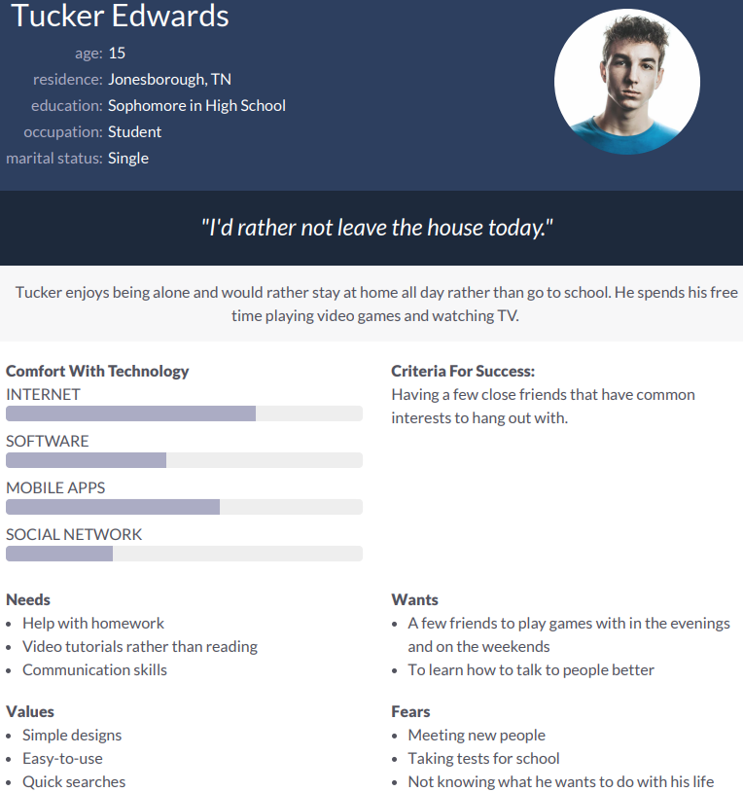

**Concern**: Tucker Edwards is exceedingly lazy and wants to buy what he wants very quickly and efficiently.

**Resolution**: To accommodate better searching, the website will include a search mechanic that will look through all items of the shopping page and return the results. As mentioned in other Persona concerns above, quick checkout will be implemented.

### Emily Ervin: Courtney Jones (Group B Female)

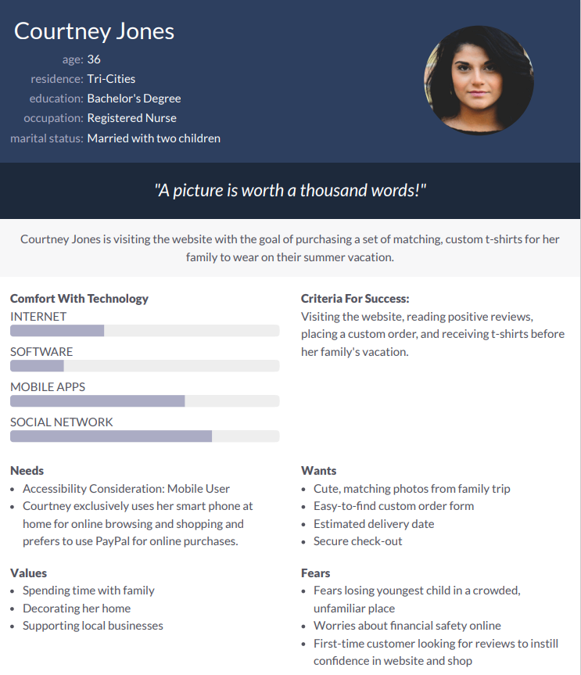

**Concern**: Courtney Jones uses her phone to buy products online, preferring to use PayPal for her online purchases.

**Resolution**: The website will be styled to work for mobile devices as well. It will be tested on mobile phones and iPad/Tablet devices.

### Emily Ervin: Kenzie King (Group A Female)

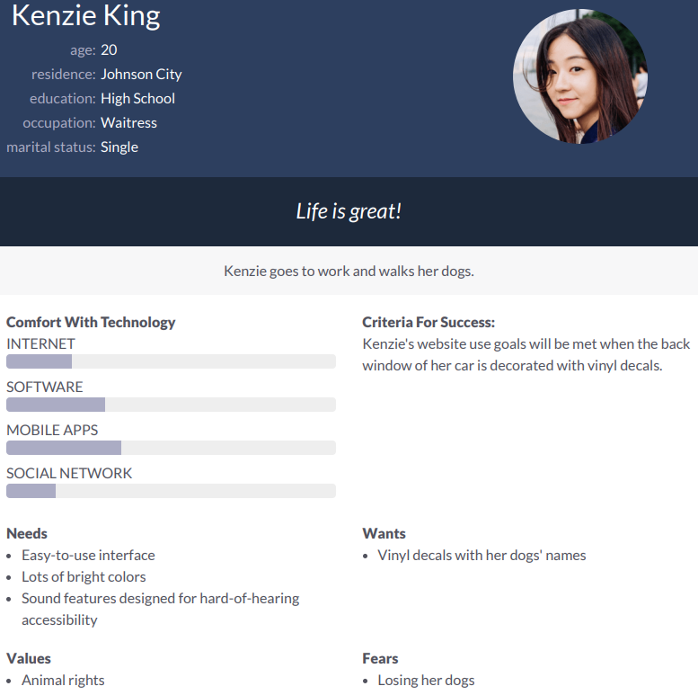

**Concern**: Kenzie King wants a special order from her client quickly, while figuring out how to get one with ease.

**Resolution**: The website will include a link to the Contact Us webpage, which has the information needed to contact the owner of Twisted Vinyl for a special order. There will also be a brief description that describes what is needed for the special order (Like when it can be done, where it is done, what vinyl is done, etc.) immediately above the contact information.